In Class ICP Programming Assignment - 2

GHITHUB LINK:<https://github.com/poojasrinivas29/icp.2/tree/main>

Video explanation link:https://drive.google.com/file/d/1uQyMltpnj0_U_0_n1aIRhrtTJsgOUIdE/view?usp=sharing

1) Create a class Employee and then do the following • Create a data member to count the number of Employees • Create a constructor to initialize name, family, salary, department • Create a function to average salary • Create a Fulltime Employee class and it should inherit the properties of Employee class • Create the instances of Fulltime Employee class and Employee class and call their member functions

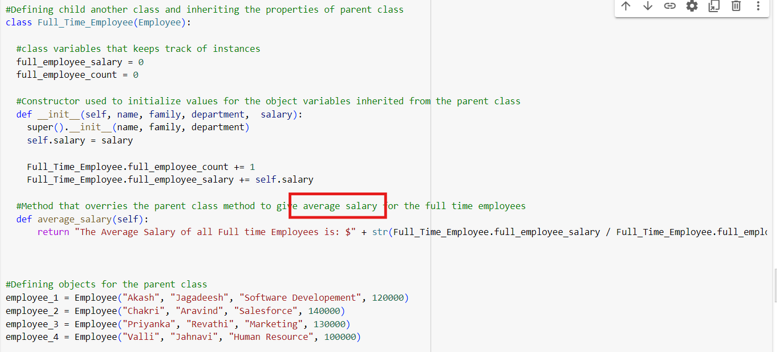

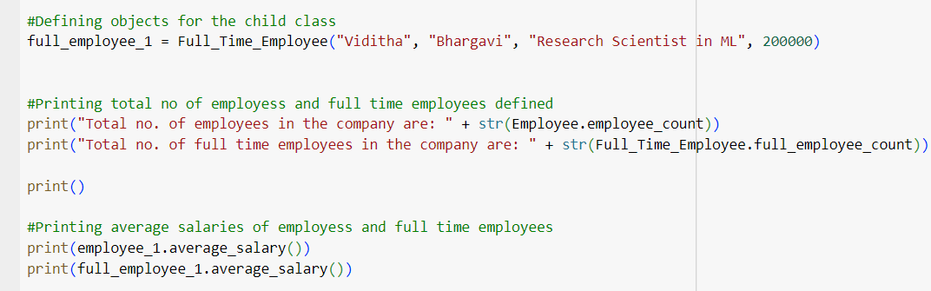

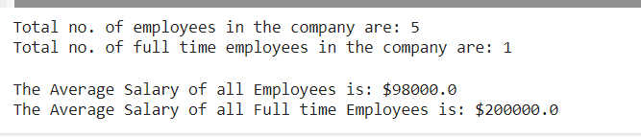

2)Numpy Using NumPy create random vector of size 20 having only float in the range 1-20. Then reshape the array to 4 by 5 Then replace the max in each row by 0 (axis=1) (you can NOT implement it via for loop)

